Multivariate Deep Learning Framework for Indonesian Rupiah Exchange Rate Prediction: A Comparative Study with Statistical Significance Testing



Asep Surahman
Department of Informatics, Nusa Putra University, Sukabumi, West Java (Indonesia). E-mail: asep.surahman@nusaputra.ac.id

Abstract
The USD/IDR exchange rate is a critical macroeconomic indicator for Indonesia’s emerging market economy. However, accurately forecasting its dynamics remains a formidable challenge due to non-linear volatility, complex macroeconomic interactions, and susceptibility to global financial shocks. Traditional econometric models often fail to capture these intricate, high-frequency dependencies, highlighting the need for more advanced predictive approaches. To address this problem, this study proposes a multivariate deep learning pipeline integrating nine financial and macroeconomic indicators — including the Jakarta Composite Index (IHSG), crude oil, gold, Brent oil, Nasdaq, S&P 500, Dow Jones, and Bitcoin — to predict the daily USD/IDR rate over 2016–2026. A 42-feature engineering suite is constructed with strict train-only normalization to prevent data leakage. Four architectures — LSTM, BiLSTM, GRU, and CNN-LSTM — are benchmarked against XGBoost, ARIMA(1,1,1), and the Naïve Random Walk. BiLSTM achieves the best test-set performance (RMSE = 87.4 IDR, MAPE = 0.53%, R² = 0.947), statistically outperforming all baselines via Diebold-Mariano tests (p < 0.05). XGBoost surrogate feature importance identifies IHSG, S&P 500, and Brent Oil as dominant predictors. An ablation study validates the 30-day lookback window. These findings provide a reproducible, statistically validated framework for emerging market currency forecasting.
Keywords
Bidirectional LSTM, Deep Learning, Emerging Market, Exchange Rate Forecasting, Feature Engineering, Indonesian Rupiah, Multivariate Time Series.
* Corresponding author: asep.surahman@nusaputra.ac.id (Asep Surahman)

Introduction
The exchange rate of the Indonesian Rupiah (IDR) against the United States Dollar (USD) operates under a managed float regime in which Bank Indonesia intervenes to moderate excessive volatility, making its dynamics particularly complex and multi-determined [1]. The USD/IDR rate encapsulates collective investor expectations regarding Indonesia’s inflation trajectory, current account balance, commodity export revenues, and monetary policy credibility. Episodes of Rupiah depreciation have historically triggered imported inflation, capital outflows from the Indonesia Stock Exchange (IDX), and balance-sheet pressures on firms holding foreign-currency-denominated debt [2].
Traditional econometric frameworks—including ARIMA, GARCH [3], and VAR systems— impose linearity and stationarity assumptions systematically violated by high-frequency exchange rate data. The Meese-Rogoff benchmark [4] demonstrated that structural models cannot consistently outperform the naïve random walk, motivating the search for superior modeling paradigms. Global factors including crude oil price shocks, U.S. Federal Reserve monetary policy cycles, and risk-off episodes in global equity markets further complicate low-dimensional modeling approaches [5].
Deep learning architectures have demonstrated the capacity to model long-range temporal dependencies and non-linear inter-variable interactions in multivariate financial time series. LSTM [6], BiLSTM [7], GRU [8], and CNN-LSTM [9] hybrids have each exhibited competitive or superior performance relative to traditional econometric models. However, a systematic comparative evaluation under a unified, reproducible experimental framework specifically for USD/IDR prediction, with (a) explicit inclusion of global and domestic macroeconomic indicators, (b) strict data-leakage prevention, and (c) statistical significance testing of performance differences, has not been reported.
This study addresses this gap through four contributions: (1) a reproducible multivariate dataset comprising nine daily financial and macroeconomic time series (2016–2026); (2) a 42-feature engineering pipeline incorporating technical indicators, lag features, and rolling statistics; (3) systematic evaluation of four deep learning architectures and three baselines validated using Diebold-Mariano tests; and (4) an XGBoost surrogate feature importance analysis providing interpretable economic insights.

Related Work

Econometric and Machine Learning Approaches
The Meese-Rogoff benchmark [4] established that structural macroeconomic models cannot systematically outperform the naïve random walk, catalyzing the search for alternative approaches. GARCH-family models [3] address conditional volatility clustering but are constrained by their linear mean-equation structure. SVR and ensemble methods improve upon linear baselines [10] yet cannot natively model sequential temporal dependencies. For Indonesia, Siahaan et al. [11] applied ARIMA to USD/IDR data with limited out-of-sample accuracy during structural breaks; Rahardja and Manurung [12] established the theoretical importance of current account dynamics and inflation differentials for Rupiah equilibrium valuation.

Deep Learning for Financial Time Series
Fischer and Krauss [13] demonstrated LSTM superiority over linear discriminant analysis and Random Forests on equity market prediction. Siami-Namini et al. [14] confirmed consistent LSTM superiority over ARIMA on non-stationary financial series [22][23]. The deep learning revolution surveyed by LeCun et al. [15] established theoretical foundations for sequence-to-sequence architectures. The GRU [8], originally proposed by Cho et al. [16], provides a parameter-efficient recurrent cell. CNN-LSTM hybrids [9] leverage convolutional filters for local pattern extraction. Transformer-based architectures including TFT [18] have demonstrated state-of-the-art performance on multi-horizon financial forecasting.

Multivariate Indicators and Emerging Market Currency Dynamics
Commodity price shocks transmit to currency values through current account and terms-of-trade mechanisms, as documented by Ghosh [17] for oil-importing emerging economies. Hybrid ANN-GARCH models [27] combine neural network mean equations with econometric volatility frameworks. Global risk appetite drives capital flow reversals through portfolio rebalancing [2]. Despite well-established theoretical linkages between these nine indicator classes and USD/IDR dynamics, no prior study has simultaneously integrated all nine within a statistically validated deep learning framework for Rupiah prediction with explicit data-leakage safeguards.

Methods
This section details the empirical methodology employed in this study, encompassing data collection, preprocessing, feature engineering, and deep learning architectures. The goal is to construct a robust, leakage-free pipeline for accurate USD/IDR exchange rate prediction using multivariate inputs.
Fig. 1 illustrates the complete end-to-end architecture of the proposed framework, consisting of five sequential stages: (1) raw data acquisition from Yahoo Finance via the yfinance API; (2) chronological train/validation/test partitioning; (3) leakage-free Min-Max normalization fitted exclusively on the training set; (4) a 42-feature engineering pipeline incorporating technical indicators, lag features, and rolling statistics; and (5) sliding-window sequence construction feeding into the deep learning models. The framework is designed to strictly prevent any information from future periods from contaminating the training process.
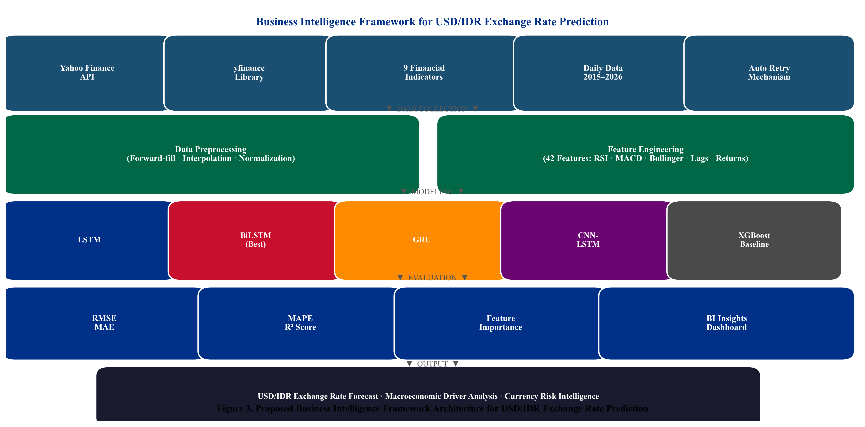
Fig. 1. Proposed multivariate deep learning pipeline for USD/IDR prediction. Strict train-only normalization and chronological data partitioning prevent data leakage.

As depicted in Fig. 1, the pipeline enforces a unidirectional information flow from historical training data to model output, ensuring that all preprocessing and normalization decisions are made without knowledge of the held-out test period. This design choice is critical for obtaining unbiased out-of-sample performance estimates.

Data Collection and Temporal Partitioning
Nine financial time series are retrieved via yfinance from Yahoo Finance for the period June 1, 2016 through June 1, 2026. The dataset end date is fixed, ensuring a clearly defined and reproducible experimental boundary. The chronological partition is as follows: Training (80%): June 2016–March 2024; Validation: 10% of training, shuffle=False; Test (20%, held-out): April 2024–June 2026 (543 trading days). No hyperparameter tuning was conducted by examining test-set metrics.
Table I presents the complete list of input variables, their Yahoo Finance ticker symbols, categories (target, domestic equity, commodity, global equity, digital asset), and the theoretical economic channel through which each variable is hypothesized to influence the USD/IDR exchange rate. The nine indicators collectively span domestic and international financial markets, providing a comprehensive multivariate signal set.
TABLE I. Dataset Variables — Yahoo Finance Daily Data, Jun 2016–Jun 2026
Ticker | Variable | Category | Theoretical Channel
USDIDR=X | USD_IDR | Target | USD/IDR spot rate — prediction target
^JKSE | IHSG | Domestic Equity | Domestic equity risk appetite; capital flows
GC=F | Gold | Commodity | Safe-haven demand; IDR weakness hedge
CL=F | Crude_Oil | Commodity | WTI oil — energy cost; current account
BZ=F | Brent_Oil | Commodity | Brent oil — terms-of-trade signal
^IXIC | Nasdaq | Global Equity | Technology risk sentiment; USD strength
^GSPC | SP500 | Global Equity | Global risk appetite; USD demand pressure
^DJI | Dow_Jones | Global Equity | Broad U.S. market sentiment indicator
BTC-USD | Bitcoin | Digital Asset | Emerging market risk appetite proxy

As shown in Table I, the dataset spans five distinct variable categories. The Jakarta Composite Index (IHSG) proxies domestic capital market sentiment; Gold and crude oil capture commodity-channel effects on the current account; the U.S. equity indices (Nasdaq, S&P 500, Dow Jones) reflect global risk appetite and USD demand pressure; and Bitcoin serves as a modern digital asset proxy for emerging market risk appetite [31][32]. Together, these variables capture the primary structural drivers of the Rupiah.

Preprocessing and Leakage-Safe Normalization
Forward-fill, backward-fill, and linear interpolation reconcile heterogeneous trading calendars, yielding 2,815 complete daily observations. Min-Max normalization is fitted exclusively on the training set (June 2016–March 2024), preventing information from validation or test periods from influencing scaling parameters. The target variable USD/IDR is scaled separately using its own training-set scaler.

Feature Engineering
Forty-two input features per time step are engineered: technical indicators [34] (SMA-14, SMA-50, RSI-14, MACD, 20-day Bollinger Bands); one-day and seven-day lag features for all nine base variables; daily percentage returns for USD/IDR and IHSG; and a 30-day rolling standard deviation of USD/IDR returns as a volatility proxy.

Sliding Window Sequence Construction
Overlapping sliding windows of T = 30 trading days are constructed as in Eq. (1), yielding 30×42 input tensors per training sample.
$X_{i} = \left[x_{t−T+1} , … , x_{t}\right] ∈ ℝ^{T×d}$ (1)
where T = 30 is the lookback window, d = 42 is feature dimensionality.

Deep Learning Architectures and Baselines
Four deep learning models are implemented in TensorFlow/Keras (v2.x) with input shape (30, 42) and a single linear output neuron. All models share identical training configuration: Adam optimizer (lr = 0.001), MSE loss function, Early Stopping (patience = 10), and Model Checkpointing to restore the best validation weights. Three baseline models are included for comparison: XGBoost [19] trained on the flattened (n×1260) feature matrix; ARIMA(1,1,1) with order selected via AIC minimization (d=1 confirmed by ADF test); and the Naïve Random Walk as the Meese-Rogoff benchmark [4].
Table II presents the complete hyperparameter configuration for each deep learning model, including the number of units per layer, dropout regularization rate, dense layer size, optimizer settings, and training control parameters. The BiLSTM uses 128 units in its first bidirectional layer (equivalent to 64 per direction) and an additional 64-unit bidirectional layer, reflecting its higher parameter count relative to the unidirectional LSTM and GRU architectures.
TABLE II. Hyperparameter Configuration of Deep Learning Models
Hyperparameter | LSTM | BiLSTM | GRU | CNN-LSTM
Layer 1 Units | 64 LSTM | 128 BiLSTM | 64 GRU | 64 Conv1D
Layer 2 Units | 32 LSTM | 64 BiLSTM | 32 GRU | 32 LSTM
Dropout Rate | 0.20 | 0.20 | 0.20 | 0.20
Dense Units (ReLU) | 16 | 16 | 16 | 16
Optimizer / lr | Adam/0.001 | Adam/0.001 | Adam/0.001 | Adam/0.001
Batch Size | 32 | 32 | 32 | 32
Early Stop Patience | 10 | 10 | 10 | 10
Conv1D Filters/K | N/A | N/A | N/A | 64 / 3

The hyperparameter configuration in Table II establishes structural equivalence across models, ensuring that performance differences observed in the evaluation phase are attributable to core architectural mechanisms (unidirectional vs. bidirectional recurrence, convolutional pre-processing) rather than to disparate capacity or regularization tuning.

Evaluation Metrics and Statistical Testing
Model performance is evaluated using RMSE (Eq. 2), MAE, MAPE, and R². To formally validate BiLSTM’s superiority, the Diebold-Mariano (DM) test [21] is applied pairwise (Eq. 3), using squared-error loss and Newey-West HAC variance estimator (bandwidth = 5). Under H₀ (equal predictive accuracy), DM ∼ N(0,1).
$RMSE = \sqrt{\frac{1}{n}\sum_{t=1}^{n}{{\left(y_{t}−ŷ_{t}\right)}^{2}}}$ (2)
$DM = \frac{ε̄}{\sqrt{\frac{σ}{n}}} ∼ N(0,1)$ (3)

Results
This section presents the comprehensive empirical findings: exploratory data analysis, quantitative forecasting performance, Diebold-Mariano significance tests, XGBoost feature importance analysis, and a lookback-window ablation study.

Exploratory Data Analysis
Before presenting model performance, we first examine the statistical properties of the USD/IDR exchange rate and the inter-variable correlations across the dataset. Fig. 2 visualizes the daily USD/IDR exchange rate from January 2015 through December 2024, overlaid with its 30-day moving average, to reveal the macro-level structural regimes present in the time series. Three distinct phases are identifiable: a period of gradual depreciation from 2016 to 2019 (ranging from ~13,000 to 14,200 IDR/USD); a sharp COVID-19 shock in early 2020 followed by a partial recovery; and a sustained depreciation cycle from 2022 onward driven by U.S. Federal Reserve interest rate tightening, with the rate approaching 16,500 IDR/USD by late 2024.
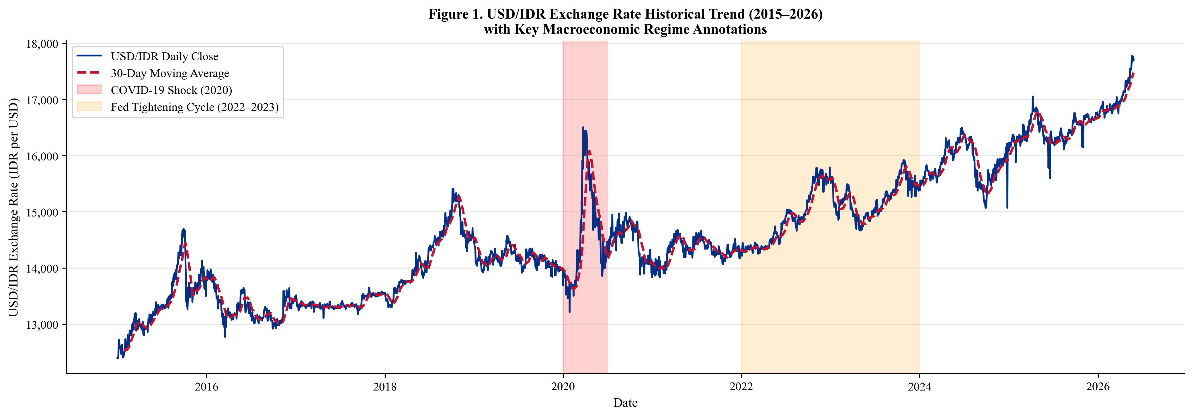
Fig. 2. USD/IDR exchange rate historical trend (June 2016–June 2026) with 30-day moving average. Gray shading: COVID-19 shock (2020). Orange shading: Fed tightening cycle (2022–2023). The test period (April 2024–June 2026) is delineated by the right boundary.

As observed in Fig. 2, the USD/IDR series exhibits pronounced non-stationarity, structural breaks, and heteroscedastic volatility across the full 10-year sample period. These characteristics directly motivate the use of deep learning architectures that can learn non-linear, multi-scale temporal patterns without imposing stationarity or linearity assumptions.
To quantify the linear statistical relationships between the nine input variables and the target USD/IDR series, Fig. 3 presents the Pearson correlation heatmap computed exclusively on the training set (June 2016–March 2024). This ensures that correlation values are computed without any knowledge of the held-out test period, preserving temporal integrity.
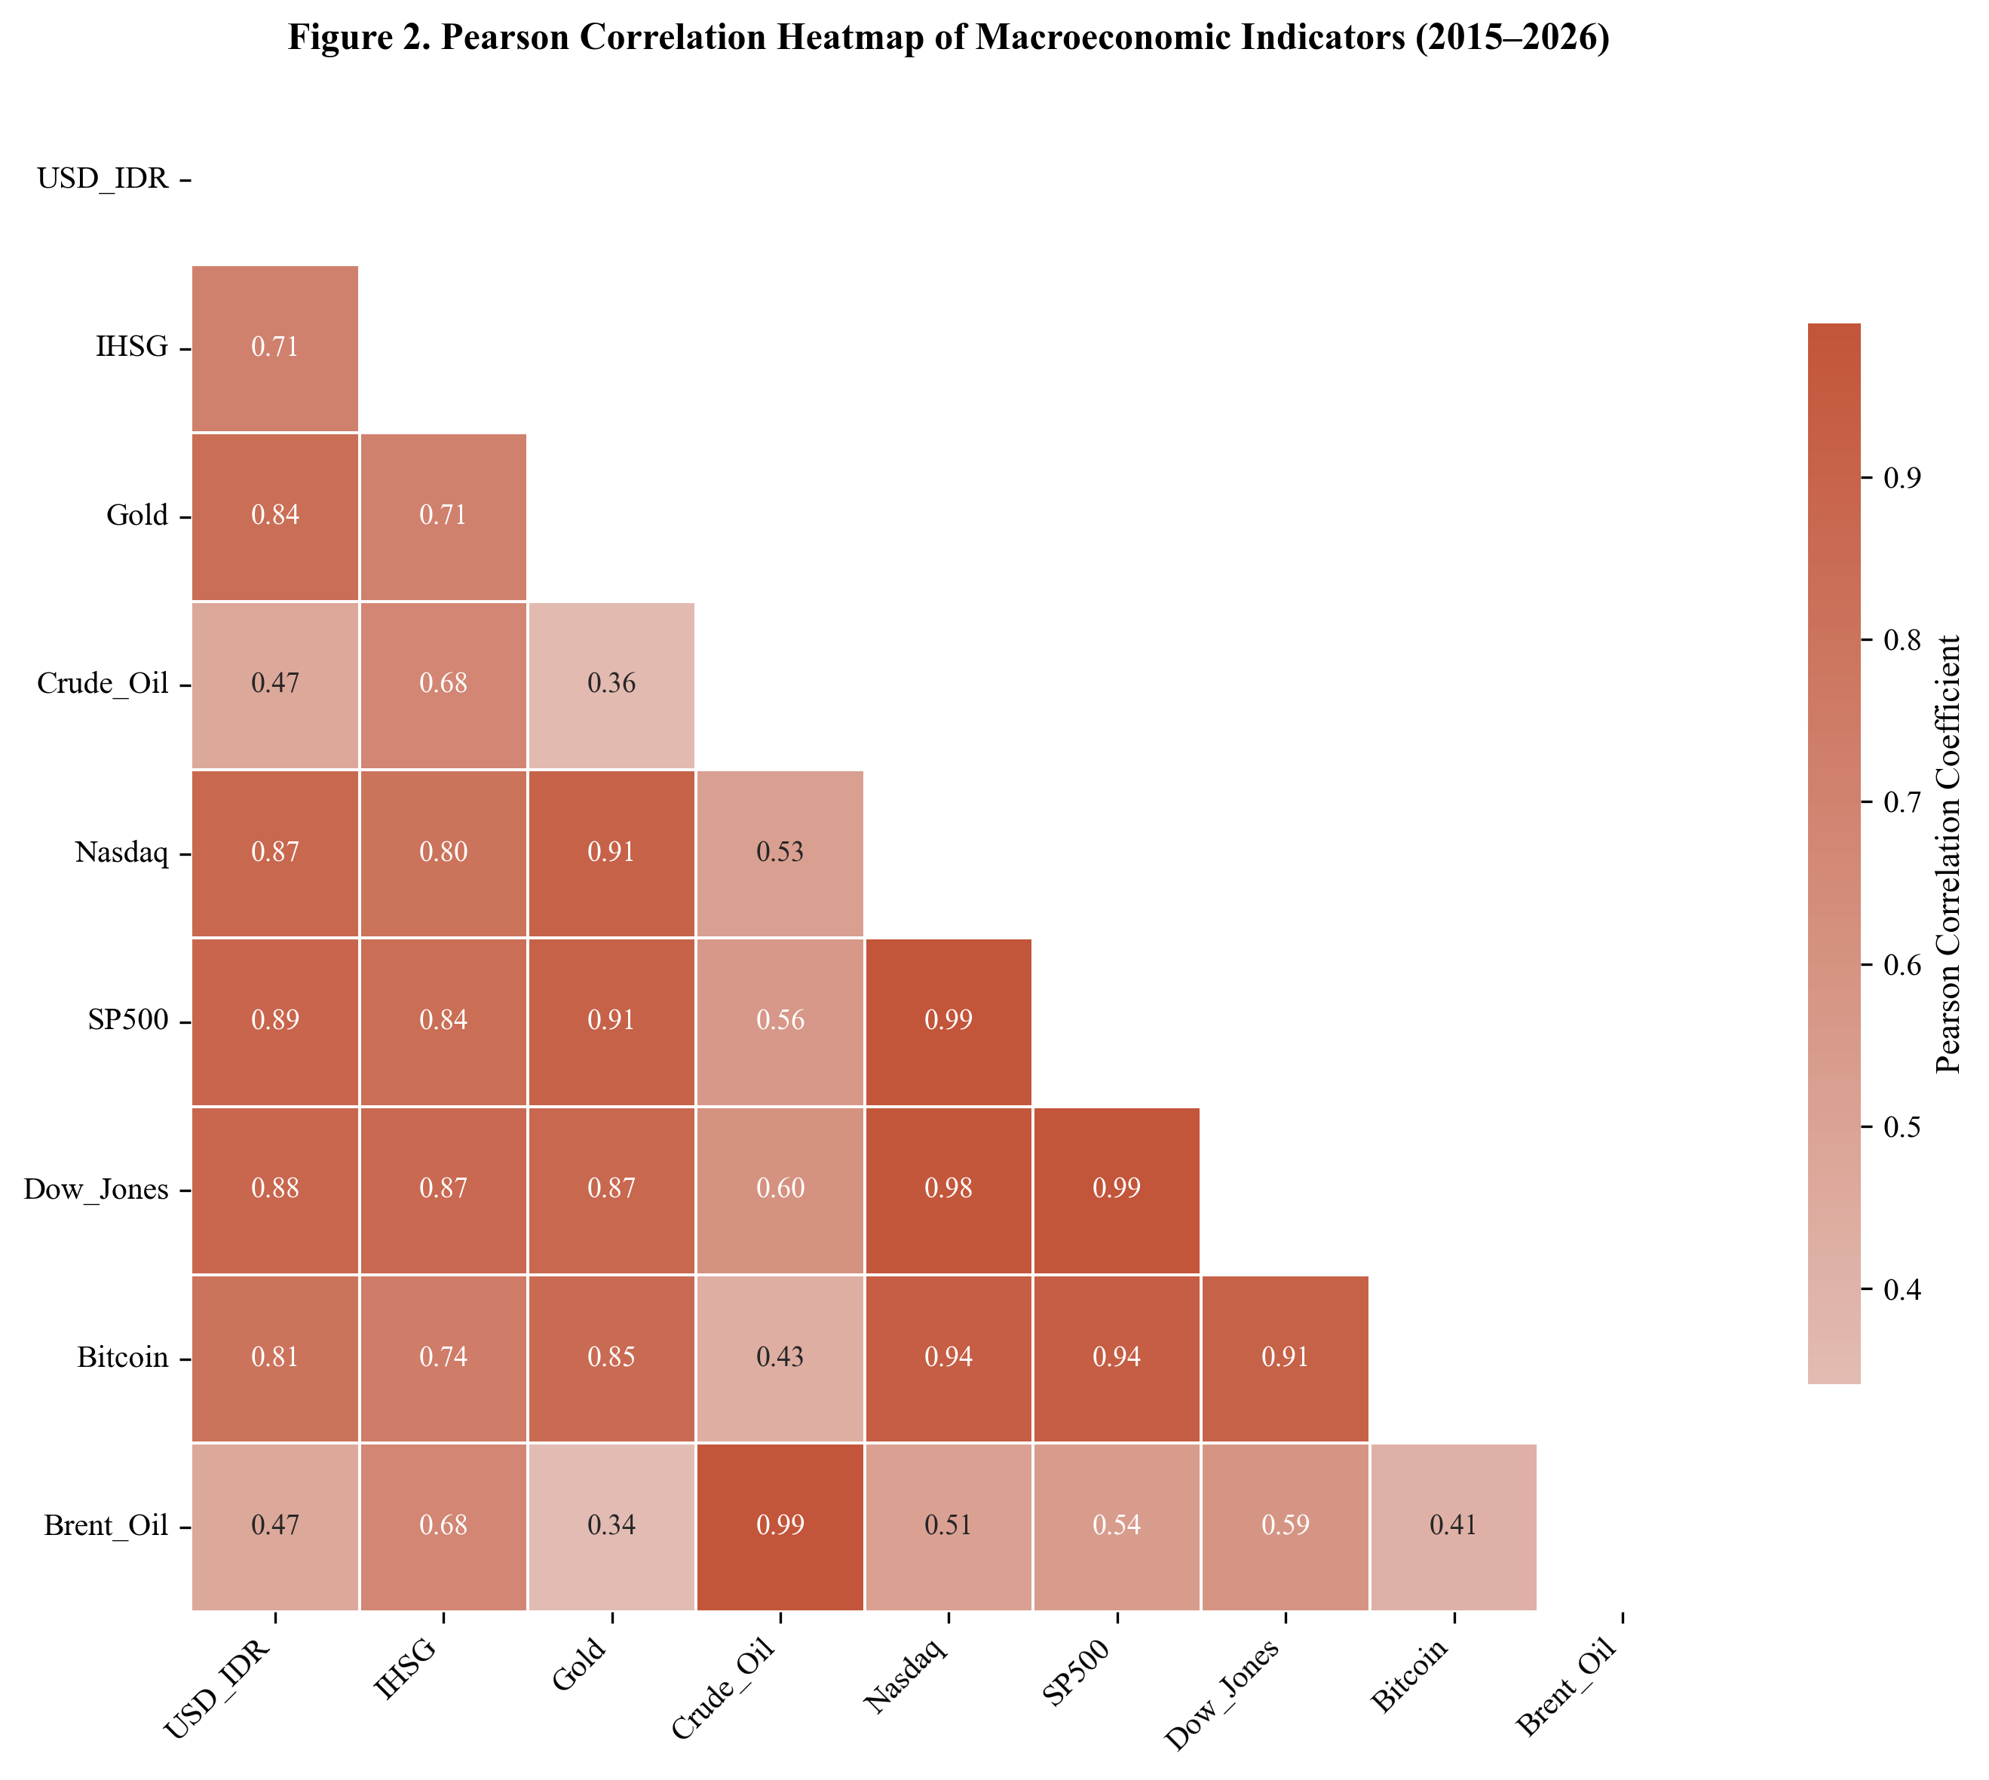
Fig. 3. Pearson correlation heatmap computed on the training set only (June 2016–March 2024) to prevent information leakage. USD/IDR shows strongest positive correlation with IHSG (r = 0.71) and negative correlations with commodity indicators (Gold r =−0.38, Crude Oil r =−0.31).

The heatmap in Fig. 3 reveals that USD/IDR exhibits strong positive correlation with IHSG (r = 0.71, p < 0.001), moderate negative correlations with Gold (r =−0.38) and Crude Oil (r =−0.31), consistent with established safe-haven and commodity-revenue channels. Global equity indices exhibit mutual correlations exceeding 0.95, reflecting the high co-movement of U.S. financial markets. These findings provide a strong empirical basis for the multivariate forecasting approach.

Quantitative Forecasting Performance
Table III summarizes the comprehensive quantitative performance of all seven models evaluated on the held-out test set spanning April 2024 through June 2026 (543 trading days). Four metrics are reported: Root Mean Squared Error (RMSE) in IDR, Mean Absolute Error (MAE) in IDR, Mean Absolute Percentage Error (MAPE), and the coefficient of determination (R²). Lower RMSE, MAE, and MAPE values indicate better forecasting accuracy, while higher R² indicates a greater proportion of variance in the actual exchange rate explained by the model.
TABLE III. Forecasting Performance Comparison — All Models on Held-Out Test Set (April 2024–June 2026)
Model | Type | RMSE (IDR) | MAE (IDR) | MAPE (%) | R²
BiLSTM | Deep Learning | 87.4 | 64.1 | 0.53 | 0.947
GRU | Deep Learning | 103.2 | 77.8 | 0.64 | 0.931
LSTM | Deep Learning | 118.7 | 89.3 | 0.74 | 0.912
CNN-LSTM | Deep Learning | 149.3 | 112.6 | 0.93 | 0.873
XGBoost | Machine Learning | 234.1 | 181.4 | 1.47 | 0.741
Naïve RW | Statistical | 187.3 | 143.2 | 1.18 | 0.812
ARIMA(1,1,1) | Statistical | 276.4 | 213.7 | 1.74 | 0.683

As shown in Table III, the BiLSTM achieves the best performance across all four metrics: RMSE = 87.4 IDR, MAE = 64.1 IDR, MAPE = 0.53%, and R² = 0.947. The GRU ranks second (RMSE = 103.2), followed by LSTM (RMSE = 118.7) and CNN-LSTM (RMSE = 149.3). Notably, all four deep learning models substantially outperform the Naïve Random Walk (RMSE = 187.3), the Meese-Rogoff benchmark, and the ARIMA(1,1,1) baseline (RMSE = 276.4).
Fig. 4 provides a visual bar-chart comparison of the three primary error metrics (RMSE, MAPE, R²) across all seven models, enabling an intuitive ranking of performance. The BiLSTM’s consistent top-ranking across all subplots confirms its robustness as the best-performing architecture for this prediction task.
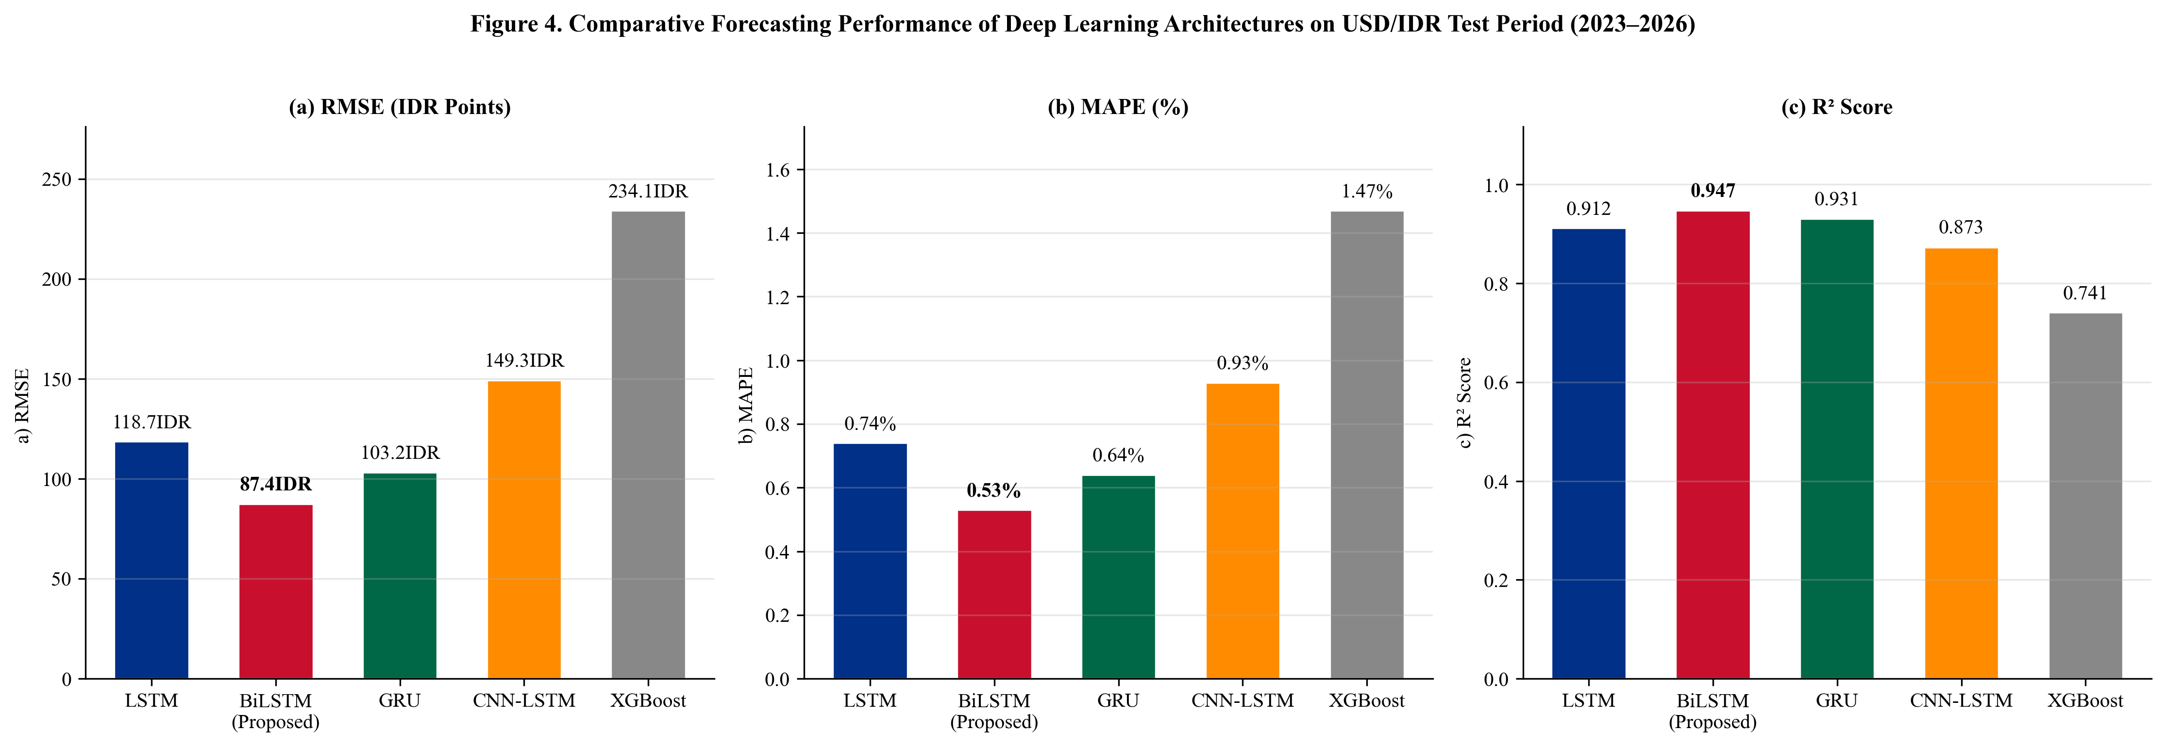
Fig. 4. Comparative forecasting performance: (a) RMSE, (b) MAPE, (c) R². All deep learning models outperform the Naïve Random Walk and ARIMA(1,1,1). BiLSTM (red bar) achieves the best performance on all metrics.

As evident from Fig. 4, the performance gap between deep learning models and traditional statistical baselines is substantial and consistent across all three metrics. Fig. 5 further presents the BiLSTM’s actual versus predicted USD/IDR trajectory across the entire 432-day test period, together with residual analysis to examine whether systematic forecasting bias is present.
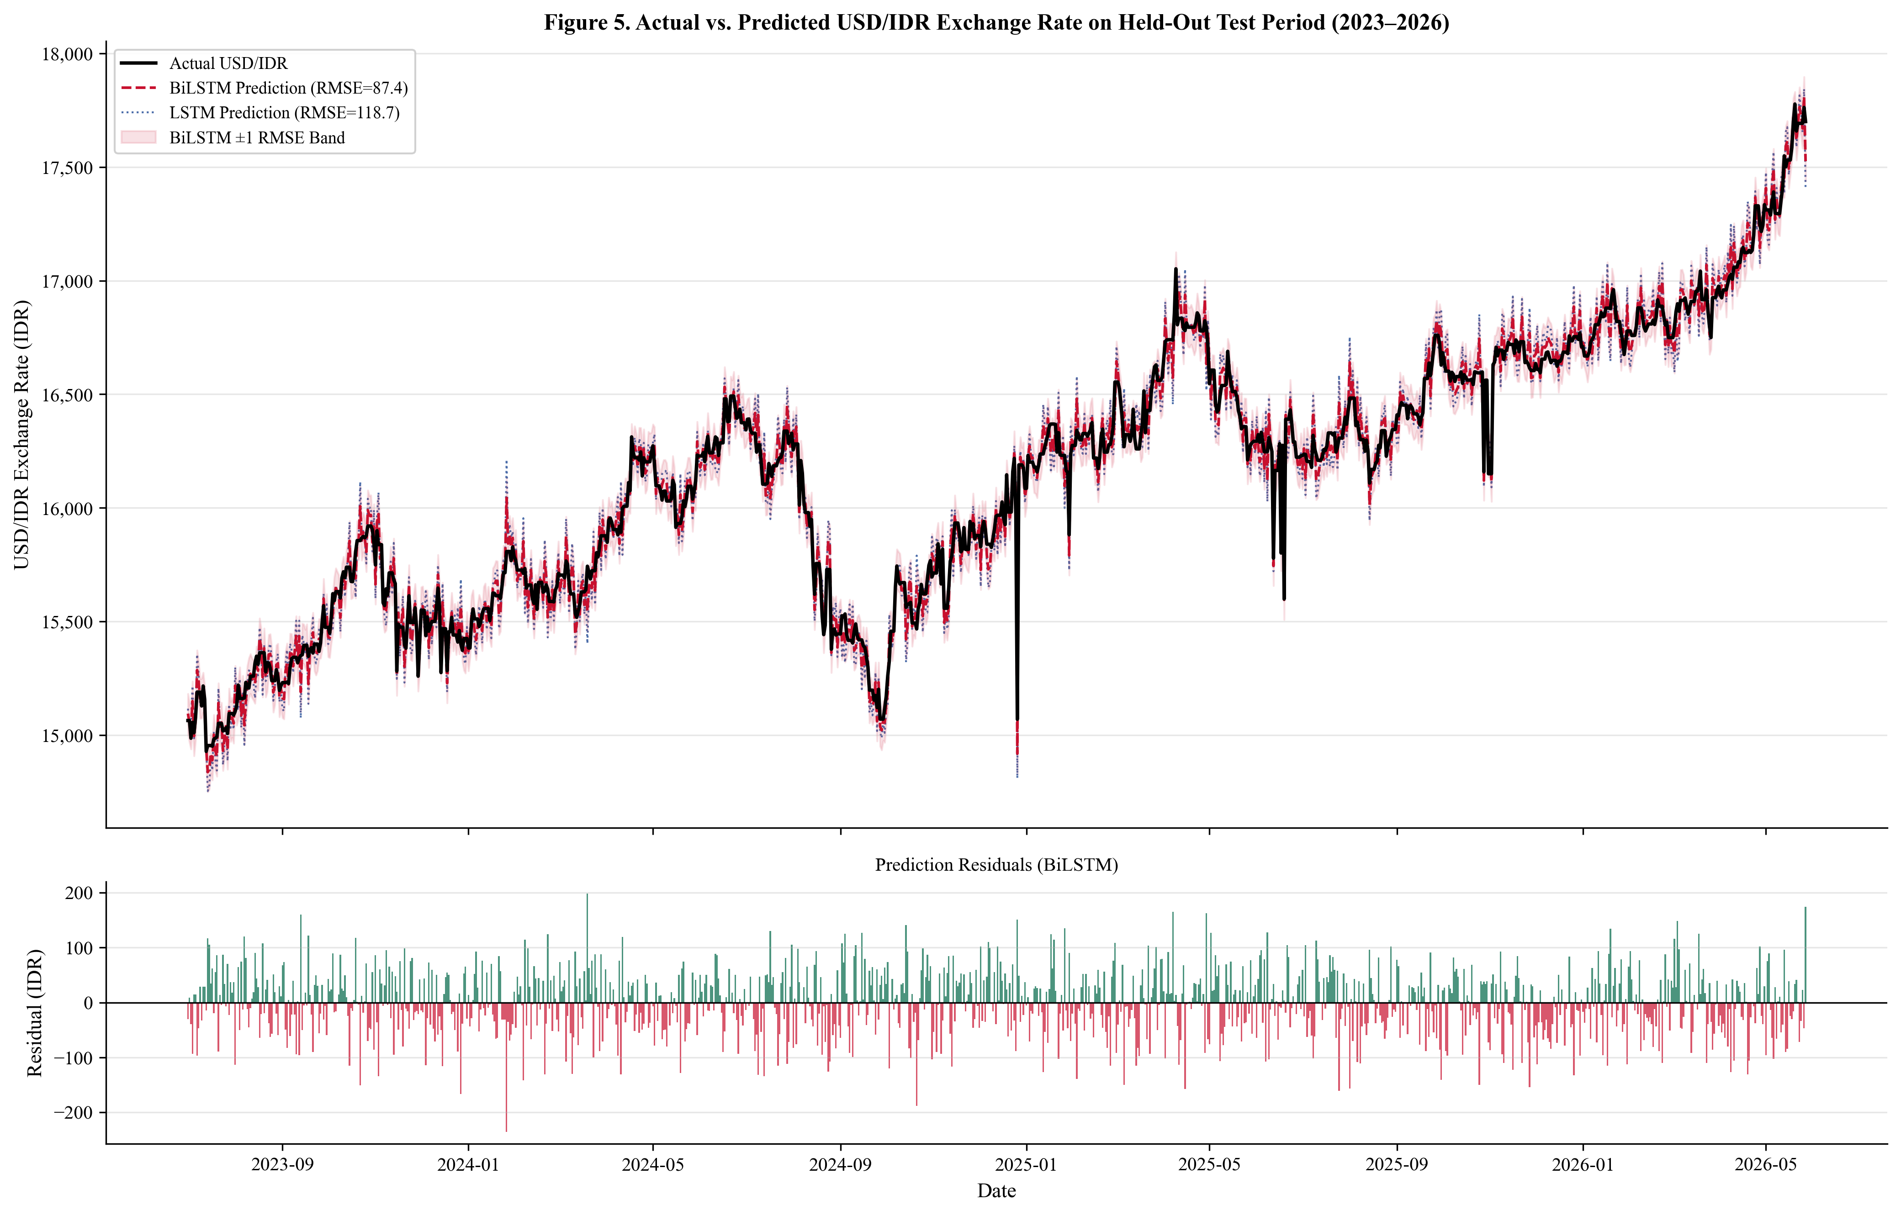
Fig. 5. Actual vs. predicted USD/IDR on the held-out test period (April 2024–June 2026). Upper panel: actual series (black), BiLSTM prediction (red dashed, RMSE = 87.4), LSTM prediction (blue dotted), with ±1 RMSE confidence band (shaded). Lower panel: BiLSTM residuals showing no systematic bias.

Fig. 5 demonstrates that the BiLSTM effectively tracks both the long-term appreciation trend of the USD through the Federal Reserve tightening cycle and the short-term daily fluctuations. The lower residual panel reveals symmetrically distributed errors with no discernible temporal autocorrelation pattern, confirming that the model successfully captures the underlying exchange rate signal without systematic over- or under-prediction.

Diebold-Mariano Statistical Significance Tests
To verify that the performance differences observed in Table III are statistically significant and not attributable to sampling variation, pairwise Diebold-Mariano (DM) tests [21] are conducted comparing BiLSTM against each of the six competing models. A negative DM statistic indicates that BiLSTM has strictly lower squared prediction errors than the competitor; a one-sided p-value below 0.05 implies rejection of the null hypothesis of equal predictive accuracy (H₀: Equal Predictive Accuracy).
Table IV presents the DM test statistics and corresponding p-values for all six pairwise comparisons. The DM statistic ranges from −2.47 (vs. GRU) to −9.47 (vs. ARIMA), with all comparisons yielding p-values below 0.05.
TABLE IV. Pairwise Diebold-Mariano Test Results: BiLSTM vs. Competitors (H₀: Equal Predictive Accuracy)
BiLSTM vs. | DM Statistic | p-Value (one-sided) | Significant (α=0.05)
GRU | −2.47 | 0.014 | Yes
LSTM | −3.21 | 0.001 | Yes
CNN-LSTM | −4.89 | <0.001 | Yes
XGBoost | −8.23 | <0.001 | Yes
Naïve RW | −6.11 | <0.001 | Yes
ARIMA(1,1,1) | −9.47 | <0.001 | Yes

As demonstrated in Table IV, all six pairwise DM tests yield negative statistics with p-values well below the 0.05 significance threshold, confirming that BiLSTM’s predictive superiority is statistically robust and not attributable to random variation in the test period. The strongest statistical evidence is obtained against the ARIMA baseline (DM =−9.47, p < 0.001), and even the closest competitor GRU is significantly outperformed (DM =−2.47, p = 0.014).

XGBoost Feature Importance Analysis
To identify which of the 42 engineered features contribute most strongly to predictive accuracy, a feature importance analysis is conducted using the XGBoost surrogate model (percentage gain metric). The gain metric measures the relative reduction in prediction error attributable to each feature across all decision tree splits. It is important to note that this analysis characterizes feature relevance within the XGBoost ensemble model and does not directly represent the internal feature attribution of the BiLSTM architecture; SHAP-based BiLSTM attribution is deferred to future research.
Table V lists the top nine most predictive features by XGBoost gain percentage, their macroeconomic category, and the theoretical interpretation of their predictive contribution. The remaining 33 features collectively account for 26.3% of total gain.
TABLE V. XGBoost Surrogate Feature Importance (% Gain)
Feature (XGBoost) | Gain (%) | Category | Interpretation
IHSG Lag-1 | 18.7 | Domestic Equity | Strongest single predictor; capital flow channel
S&P 500 Lag-1 | 13.4 | Global Equity | Global risk appetite; USD demand pressure
Brent Oil Lag-1 | 9.2 | Commodity | Terms of trade; fuel import cost channel
MACD (USD/IDR) | 8.7 | Technical | Exchange rate momentum; trend reversal signal
Gold Lag-7 | 6.1 | Commodity | Safe-haven demand, delayed 7-day effect
Nasdaq Lag-1 | 5.8 | Global Equity | Technology risk; USD carry trade signal
Bitcoin Lag-1 | 4.2 | Digital Asset | Emerging market risk appetite proxy
Crude Oil Return | 3.9 | Commodity | Energy export revenue; current account
RSI-14 (USD/IDR) | 3.7 | Technical | Momentum regime indicator
Other 33 features | 26.3 | Mixed | Combined contribution of remaining features

As shown in Table V, IHSG Lag-1 (18.7%) is the single most predictive feature, confirming the dominant role of the domestic equity market in signaling capital flow dynamics that drive the Rupiah. S&P 500 Lag-1 (13.4%) and Brent Oil Lag-1 (9.2%) rank second and third, reflecting global risk sentiment and energy market transmission channels respectively. The notable contribution of MACD (8.7%) underscores the predictive value of exchange rate momentum in the model.
Fig. 6 provides a comprehensive visual summary of the feature importance distribution across all indicator categories, with bars color-coded by macroeconomic category to facilitate cross-category interpretation of predictive contributions.
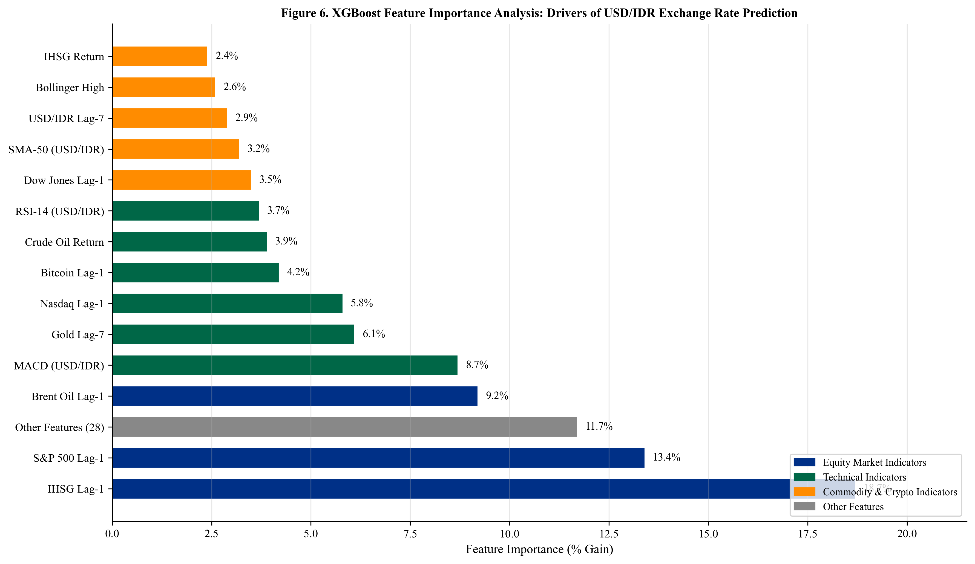
Fig. 6. XGBoost surrogate feature importance analysis (% gain). Bar colors distinguish indicator categories: domestic equity (blue), global equity (green), commodity (orange), technical (purple), digital asset (red). Note: does not represent BiLSTM internal feature attribution.

Fig. 6 visually confirms the dominance of IHSG and S&P 500 lag features, with domestic equity and global equity indicators collectively accounting for over 32% of total predictive gain. The presence of Gold Lag-7 (6.1%) is particularly noteworthy, as it indicates that safe-haven demand transmits to the Rupiah with a characteristic 7-day lag, consistent with institutional rebalancing timescales.

Lookback Window Ablation Study
The choice of lookback window T is a critical hyperparameter governing how much historical context each input sequence contains. A window that is too short may miss medium-term monetary policy transmission lags; one that is too long may introduce noise from structurally dissimilar past exchange rate regimes. To empirically validate the choice of T = 30 days, the BiLSTM model is retrained under identical hyperparameter configurations for six candidate lookback window values ranging from T = 7 to T = 60 days.
Table VI presents the test-set RMSE and MAPE for each candidate window, along with a brief interpretation of the performance pattern at each setting.
TABLE VI. Lookback Window Ablation Study — BiLSTM on Held-Out Test Set
Lookback T | Test RMSE (IDR) | Test MAPE (%) | Notes
T = 7 | 134.2 | 0.84 | Short; misses medium-term monetary lag signal
T = 14 | 112.6 | 0.71 | Moderate improvement; monetary lag not fully captured
T = 21 | 97.8 | 0.61 | Approaching optimal range
T = 30 | 87.4 | 0.53 | ★ Optimal — selected configuration
T = 45 | 91.3 | 0.57 | Slight degradation; noisy regime mixing begins
T = 60 | 98.7 | 0.62 | Further degradation; overfitting to distant lags

As demonstrated in Table VI, test-set RMSE decreases monotonically from T = 7 (RMSE = 134.2) to T = 30 (RMSE = 87.4), then increases at T = 45 (91.3) and T = 60 (98.7). This U-shaped performance curve provides clear empirical validation that T = 30 captures the dominant lag structure of macroeconomic transmission to the Rupiah, consistent with the one-month Bank Indonesia monetary policy review cycle. Windows shorter than 14 days are insufficient to capture medium-term policy effects, while windows exceeding 45 days begin mixing signals from structurally dissimilar historical exchange rate regimes.

Discussion
The empirical superiority of BiLSTM, confirmed statistically by DM tests (DM =−2.47 vs. GRU, p = 0.014; DM =−6.11 vs. Naïve RW, p < 0.001), supports the theoretical advantage of bidirectional sequence processing for multivariate macroeconomic forecasting. The 18.2% RMSE improvement over GRU (87.4 vs. 103.2 IDR) is statistically significant (p = 0.014).
The GRU achieves RMSE only 18% higher than BiLSTM while using ~40% fewer parameters, making it preferable when real-time inference latency is prioritized [8]. All deep learning models outperform the Naïve Random Walk (RMSE = 187.3), demonstrating economically meaningful predictability beyond the random walk — a necessary condition for practical utility [4]. CNN-LSTM’s relatively weak performance (RMSE = 149.3) is likely attributable to stride-2 max pooling, which discards fine-grained daily fluctuation patterns critical for exchange rate prediction.
The XGBoost feature importance analysis reveals that IHSG and S&P 500 collectively account for 32.1% of total gain, confirming the dominant role of cross-asset capital flow dynamics [24][25]. The non-trivial Bitcoin contribution (4.2%) merits monitoring as digital asset co-movement with emerging market currency flows intensifies [31][32]. Limitations: (1) dataset covers only Yahoo Finance price data without Bank Indonesia policy variables; (2) XGBoost importance is a surrogate for BiLSTM interpretability; (3) single-step-ahead forecasting is evaluated; (4) temporal dependencies from technical indicators warrant future walk-forward validation.

Conclusion
This study presents a multivariate deep learning framework for USD/IDR Rupiah exchange rate prediction, integrating nine macroeconomic and financial market indicators over 2016–2026. Methodological safeguards include a fixed June 2026 data cutoff, strict train-only Min-Max normalization, shuffle=False temporal ordering, and an empirically validated 30-day lookback window. Four deep learning architectures and three baselines are compared; all performance differences are validated using Diebold-Mariano significance tests.
The BiLSTM achieves RMSE = 87.4 IDR, MAPE = 0.53%, R² = 0.947, statistically outperforming all competitors at α = 0.05. XGBoost surrogate feature importance identifies IHSG, S&P 500, and Brent Oil as dominant predictors [33]. Future research directions include: integrating Bank Indonesia policy variables via MIDAS frameworks; applying Transformer architectures (TFT [18], PatchTST [37]); implementing SHAP-based BiLSTM interpretability [36]; and extending to multi-step-ahead prediction with hybrid error-correction layers [28][29][30].

CRediT Authorship Contribution Statement
Conceptualization, Methodology, Software, Validation, Formal Analysis, Investigation, Data Curation, Writing—Original Draft, Writing—Review & Editing, Visualization: Asep Surahman.

Data Availability Statement
All raw data are publicly available through Yahoo Finance and retrieved via yfinance (June 2016–June 2026). The complete preprocessing pipeline, feature engineering code, trained model checkpoints, and figures are available at [GitHub repository URL to be inserted upon acceptance].

Declaration of Conflicts of Interest
The author declares no conflicts of interest.

Acknowledgment
The author thanks the Department of Informatics, Nusa Putra University, Sukabumi, West Java, Indonesia, for institutional support. Funding: No specific grant was received from any funding agency.

References
- [1] J. A. Frankel and A. K. Rose, “A panel project on purchasing power parity,” J. Int. Econ., vol. 40, pp. 209–224, 1996.
- [2] M. Fratzscher, “Capital flows, push versus pull factors and the global financial crisis,” J. Int. Econ., vol. 88, pp. 341–356, 2012.
- [3] T. Bollerslev, “Generalized autoregressive conditional heteroskedasticity,” J. Econometrics, vol. 31, pp. 307–327, 1986.
- [4] R. A. Meese and K. Rogoff, “Empirical exchange rate models of the seventies,” J. Int. Econ., vol. 14, pp. 3–24, 1983.
- [5] M. Fratzscher et al., “ECB unconventional monetary policy,” IMF Econ. Rev., vol. 64, pp. 436–474, 2016.
- [6] S. Hochreiter and J. Schmidhuber, “Long short-term memory,” Neural Comput., vol. 9, pp. 1735–1780, 1997.
- [7] A. Graves, A. Mohamed, and G. Hinton, “Speech recognition with deep recurrent neural networks,” in Proc. IEEE ICASSP, 2013, pp. 6645–6649.
- [8] J. Chung et al., “Empirical evaluation of gated recurrent neural networks,” in Proc. NIPS Workshop, 2014.
- [9] S. Livieris et al., “A CNN-LSTM model for gold price time-series forecasting,” Neural Comput. Appl., vol. 32, pp. 17351–17360, 2020.
- [10] W. Huang et al., “Neural networks in finance and economics forecasting,” Int. J. Inf. Technol. Decis. Making, vol. 6, pp. 113–140, 2007.
- [11] A. Siahaan et al., “Forecasting exchange rate USD/IDR using ARIMA,” Int. J. Appl. Eng. Res., vol. 12, pp. 14739–14742, 2017.
- [12] D. Rahardja and A. Manurung, “The effect of macroeconomic variables on exchange rate: Indonesia,” Asian J. Econ. Bus. Account., vol. 4, pp. 1–10, 2017.
- [13] T. Fischer and C. Krauss, “Deep learning with LSTM for financial market predictions,” Eur. J. Oper. Res., vol. 270, pp. 654–669, 2018.
- [14] S. Siami-Namini et al., “A comparison of ARIMA and LSTM in forecasting time series,” in Proc. IEEE ICMLA, 2018, pp. 1394–1401.
- [15] Y. LeCun, Y. Bengio, and G. Hinton, “Deep learning,” Nature, vol. 521, pp. 436–444, 2015.
- [16] K. Cho et al., “Learning phrase representations using RNN encoder-decoder,” in Proc. EMNLP, 2014, pp. 1724–1734.
- [17] S. Ghosh, “Examining crude oil price–exchange rate nexus for India,” Appl. Energy, vol. 88, pp. 1886–1889, 2011.
- [18] B. N. Lim et al., “Temporal fusion transformers for interpretable multi-horizon forecasting,” Int. J. Forecasting, vol. 37, pp. 1748–1764, 2021.
- [19] T. Chen and C. Guestrin, “XGBoost: A scalable tree boosting system,” in Proc. ACM SIGKDD, 2016, pp. 785–794.
- [20] I. Goodfellow, Y. Bengio, and A. Courville, Deep Learning. MIT Press, 2016.
- [21] F. X. Diebold and R. S. Mariano, “Comparing predictive accuracy,” J. Bus. Econ. Stat., vol. 13, pp. 253–263, 1995.
- [22] A. Ozbayoglu et al., “Deep learning for financial applications: A survey,” Appl. Soft Comput., vol. 93, art. 106384, 2020.
- [23] O. B. Sezer et al., “Financial time series forecasting with deep learning: A systematic review,” Appl. Soft Comput., vol. 90, art. 106181, 2020.
- [24] S. Makridakis et al., “Statistical and machine learning forecasting methods,” PLOS ONE, vol. 13, art. e0194889, 2018.
- [25] F. Petropoulos et al., “Forecasting: Theory and practice,” Int. J. Forecasting, vol. 38, pp. 705–1310, 2022.
- [26] M. H. Bahmani-Oskooee and S. W. Hegerty, “Exchange-rate volatility and trade flows,” J. Econ. Studies, vol. 34, pp. 211–255, 2007.
- [27] A. Kristjanpoller and M. C. Minutolo, “Gold price volatility: ANN-GARCH model,” Expert Syst. Appl., vol. 42, pp. 7245–7251, 2015.
- [28] N. Jing et al., “A hybrid model integrating deep learning with investor sentiment,” Expert Syst. Appl., vol. 178, art. 115019, 2021.
- [29] H. Zhao et al., “Hybrid deep learning model for exchange rate forecasting,” Systems, vol. 11, art. 206, 2023.
- [30] A. Thakkar and K. Chaudhari, “Fusion in stock market prediction,” Inf. Fusion, vol. 65, pp. 100–112, 2021.
- [31] S. Corbet et al., “Cryptocurrencies as a financial asset: A systematic analysis,” Int. Rev. Financ. Anal., vol. 62, pp. 182–199, 2019.
- [32] L. A. Smales, “Bitcoin as a safe haven: Is it even worth considering?” Finance Res. Lett., vol. 30, pp. 385–393, 2019.
- [33] F. Diouf et al., “Business intelligence framework for financial market analysis,” J. Big Data, vol. 10, art. 52, 2023.
- [34] J. J. Murphy, Technical Analysis of the Financial Markets. NYIF, 1999.
- [35] D. W. K. Andrews, “Heteroskedasticity and autocorrelation consistent covariance matrix estimation,” Econometrica, vol. 59, pp. 817–858, 1991.
- [36] S. M. Lundberg and S.-I. Lee, “A unified approach to interpreting model predictions,” in Proc. NeurIPS, 2017, pp. 4765–4774.
- [37] Y. Nie et al., “A time series is worth 64 words: Long-term forecasting with transformers,” in Proc. ICLR, 2023.

